Maternal Toxoplasma gondii Infection and Adverse Pregnancy Outcomes: A Systematic Review and Meta-analysis
Running title: Maternal toxoplasmosis and pregnancy outcomes
Review Article / Systematic Review and Meta-analysis
Harminarti, N.a*, Luthfiya, A.R.b, Usmi, Z.A.b
a Department of Parasitology, Faculty of Medicine, Universitas Andalas, Kampus Universitas Andalas Limau Manis, Padang, West Sumatra 25163, Indonesia.
b Faculty of Medicine, Universitas Andalas, Kampus Universitas Andalas Limau Manis, Padang, West Sumatra 25163, Indonesia.
* Corresponding author: Nora Harminarti, Department of Parasitology, Faculty of Medicine, Universitas Andalas, Padang, Indonesia. Email: noraharminarti@med.unand.ac.id

Abstract
Maternal Toxoplasma gondii infection has been linked to miscarriage, preterm birth, low birth weight and impaired fetal growth, but the available observational evidence is heterogeneous. This revised systematic review and meta-analysis reassessed full texts and extracted reproducible study-level data from primary studies evaluating maternal T. gondii infection and adverse pregnancy outcomes. PubMed, Scopus and Google Scholar records were screened using a systematic strategy. After full-text reassessment, 13 primary studies were retained for qualitative synthesis and 12 contributed data to outcome-specific meta-analyses. Random-effects models were used to pool odds ratios (ORs) separately for pregnancy loss/bad obstetric history, preterm birth, low birth weight and small-for-gestational-age outcomes. Maternal T. gondii infection was associated with pregnancy loss, bad obstetric history or related adverse pregnancy events (pooled OR 3.94, 95% CI 2.14-7.24; I2=86.1%). Associations with preterm birth (pooled OR 1.22, 95% CI 0.79-1.88; I2=65.8%) and low birth weight (pooled OR 1.33, 95% CI 0.82-2.16; I2=60.7%) were not statistically significant in the revised pooled analyses. One large study showed increased odds of small-for-gestational-age birth among women with latent toxoplasmosis (OR 1.57, 95% CI 1.13-2.17). The revised evidence supports a clinically important association between maternal T. gondii infection and pregnancy loss-related outcomes, while evidence for preterm birth and low birth weight remains heterogeneous. These findings should be interpreted cautiously because diagnostic methods, exposure definitions and comparator groups varied across studies.
Keywords: Toxoplasma gondii; toxoplasmosis; pregnancy; adverse pregnancy outcomes; meta-analysis

Introduction
Toxoplasma gondii is an obligate intracellular protozoan parasite with worldwide distribution. In humans, infection is frequently asymptomatic, but maternal infection is clinically important because tachyzoites may cross the placenta and cause fetal infection, particularly when primary infection occurs during pregnancy.
Adverse pregnancy outcomes attributed to maternal toxoplasmosis include spontaneous abortion, fetal loss, stillbirth, preterm birth, low birth weight, small-for-gestational-age birth and congenital abnormalities. However, observational studies differ substantially in population, diagnostic method, exposure definition and outcome reporting. Some studies assess acute infection using IgM or avidity testing, while others evaluate latent infection using IgG seropositivity or complement-fixation profiles.
The earlier version of this review included studies with heterogeneous objectives, including seroprevalence or infection risk-factor studies and secondary reviews. After full-text reassessment, the present revision focuses on primary studies with extractable adverse pregnancy outcome data and comparator groups. The objective was to provide a transparent, reproducible synthesis of the association between maternal T. gondii infection and adverse pregnancy outcomes using outcome-specific meta-analyses.

Materials and Methods
Study design and reporting
This study was conducted as a revised systematic review and meta-analysis of observational studies assessing maternal T. gondii infection in relation to adverse pregnancy outcomes. The revision followed PRISMA principles and was undertaken after a full-text reassessment of all candidate studies previously considered for quantitative synthesis.
Data sources and search strategy
PubMed, Scopus and Google Scholar were searched using terms related to toxoplasmosis, pregnancy and adverse pregnancy outcomes. Search terms included combinations of “Toxoplasma gondii”, “toxoplasmosis”, “pregnancy”, “pregnant women”, “miscarriage”, “abortion”, “bad obstetric history”, “preterm birth”, “low birth weight”, “small for gestational age” and “adverse pregnancy outcome”.
Eligibility criteria
Studies were eligible for the revised synthesis if they were primary human studies; included pregnant women, women with pregnancy loss, or women with bad obstetric history; assessed T. gondii infection by serological or molecular methods; and reported an adverse pregnancy outcome with a comparator group or extractable two-by-two data. Secondary reviews, meta-analyses, seroprevalence-only studies, infection risk-factor studies without pregnancy outcome data, studies without extractable comparator data and studies outside the revised eligibility scope were excluded from the quantitative synthesis. Zeinali et al. (2023) was retained for narrative discussion because it provided molecular evidence in aborted fetal tissue but did not include a normal-pregnancy comparator group suitable for pooled effect estimation.
Study selection and data extraction
Titles, abstracts and full texts were reassessed. Extracted variables included author, year, country, study design, sample size, exposure definition, outcome definition, number of exposed and unexposed participants with and without outcome, and reported effect estimates. For case-control studies, the exposed and unexposed counts were arranged to estimate the odds of adverse outcome in relation to T. gondii seropositivity. When both crude and adjusted estimates were available, crude two-by-two data were used for reproducibility in the pooled analysis, and adjusted estimates were described in the text.
Quality assessment
Methodological quality was assessed descriptively using domains adapted from the Newcastle-Ottawa Scale: selection of study groups, comparability or adjustment for confounding, and outcome or exposure assessment. Studies with clear source populations, laboratory-confirmed exposure and defined outcomes were considered lower risk within the relevant domains. Studies with limited confounder control, small controls, or broad BOH definitions were rated as having unclear comparability.
Statistical analysis
Odds ratios (ORs) and 95% confidence intervals (CIs) were calculated from extracted two-by-two data. Random-effects meta-analysis was performed with the DerSimonian-Laird method because between-study heterogeneity was expected. Analyses were stratified by outcome group: pregnancy loss/bad obstetric history/adverse pregnancy events, preterm birth/prematurity, low birth weight and small-for-gestational-age birth. Heterogeneity was assessed using the Q statistic and I2. A continuity correction of 0.5 was planned for zero cells; however, no zero-cell correction was required for the primary pooled groups except where explicitly indicated in sensitivity checks.

Results
Study selection
The original database search identified 520 records. After removal of 60 duplicate records, 460 records were screened. Seventy full-text reports were assessed for eligibility. Following revised full-text reassessment, 13 primary studies were retained for qualitative synthesis and 12 primary studies contributed extractable data to at least one meta-analysis. The revised PRISMA flow diagram is shown in Figure 1.
Characteristics of included studies
The quantitative dataset comprised 12 primary studies published between 2012 and 2024. Designs included cohort, cross-sectional, retrospective cohort and case-control studies. The outcome categories were pregnancy loss/bad obstetric history, preterm birth, low birth weight and small-for-gestational-age birth. Zeinali et al. (2023) was retained narratively because it examined women with miscarriage and aborted fetal tissue using serology and PCR, but it lacked a control group of women without miscarriage.
Pregnancy loss, bad obstetric history and adverse pregnancy events
Eight studies contributed to the pregnancy loss/bad obstetric history/adverse pregnancy event subgroup. The pooled random-effects estimate showed higher odds of these outcomes among women with T. gondii infection or seropositivity (pooled OR 3.94, 95% CI 2.14-7.24; I2=86.1%). Heterogeneity was substantial, reflecting different definitions of pregnancy loss, threatened abortion, recurrent fetal loss and broader bad obstetric history.
Preterm birth and prematurity
Four studies contributed data to the preterm birth/prematurity subgroup. The pooled estimate was not statistically significant (pooled OR 1.22, 95% CI 0.79-1.88; I2=65.8%). Hurt et al. (2022) and Mutka et al. (2023) suggested increased odds, while Fochi et al. (2015) and Mocanu et al. (2022) did not show an increased association.
Low birth weight
Four studies contributed data to the low birth weight subgroup. The pooled estimate did not reach statistical significance (pooled OR 1.33, 95% CI 0.82-2.16; I2=60.7%). Hurt et al. (2022) and Parvin et al. (2022) suggested increased risk, whereas Fochi et al. (2015) and Mocanu et al. (2022) reported null or non-significant findings.
Small for gestational age
One large study contributed extractable data for small-for-gestational-age birth. Hurt et al. (2024) reported increased odds of SGA among women with latent toxoplasmosis (OR 1.57, 95% CI 1.13-2.17). Because only one study contributed directly extractable SGA data, this outcome was summarized as a single-study estimate rather than a pooled meta-analysis.
Quality assessment
Most included studies used laboratory-based exposure assessment, mainly ELISA, IgG/IgM testing, complement-fixation testing or a combination of serological approaches. The main methodological limitations were heterogeneity in outcome definitions, incomplete adjustment for confounding and broad case definitions in some BOH studies. Cohort studies with defined pregnancy outcomes and comparator groups were considered more reproducible for quantitative synthesis than seroprevalence-only studies.

Discussion
This revised review directly addresses the methodological concern that the previous quantitative synthesis included studies that did not consistently match the outcome-focused eligibility criteria. After re-screening, secondary reviews, seroprevalence-only studies and studies without extractable adverse pregnancy outcome comparators were excluded from the quantitative synthesis. The revised analysis is therefore based on primary studies with extractable study-level data.
The strongest revised evidence was observed for pregnancy loss-related outcomes, including spontaneous abortion, threatened abortion, recurrent fetal loss and bad obstetric history. The pooled estimate suggested increased odds of these outcomes among women with T. gondii infection or seropositivity. However, heterogeneity was high, and the broad grouping of related outcomes should be interpreted as evidence of association rather than a precise estimate for a single clinical endpoint.
Evidence for preterm birth and low birth weight was less consistent. Some large cohort studies reported increased odds, but other studies showed null findings. This inconsistency may reflect differences in infection stage, diagnostic assays, timing of exposure assessment, population risk, treatment status and adjustment for obstetric confounders. It also supports the decision to analyze outcomes separately instead of presenting a single overall pooled OR for all adverse outcomes.
The single-study estimate for small-for-gestational-age birth suggests that latent toxoplasmosis may be associated with fetal growth restriction at term. Because this result is based on one primary study with extractable SGA data, it should be considered hypothesis-generating and should be tested in additional cohorts.
This review has limitations. First, many studies were observational and some were hospital-based, increasing the possibility of selection bias. Second, exposure definitions varied; IgM positivity, IgG seropositivity, latent infection and combined serological profiles may represent different biological states. Third, several BOH studies grouped multiple clinical outcomes together, which limits outcome specificity. Fourth, the number of studies in some subgroups was small, and publication bias assessment was not considered reliable for subgroups with few studies.
In conclusion, the revised evidence supports an association between maternal T. gondii infection and pregnancy loss-related adverse outcomes. Evidence for preterm birth and low birth weight remains heterogeneous and was not statistically significant in the revised subgroup analyses. Future studies should use standardized serological definitions, specify infection timing, report outcome-specific two-by-two data, and adjust for major obstetric and socioeconomic confounders.

Conflict of Interests
The authors declare that they have no conflict of interests.

Funding
No specific funding was received for this work.

Data Availability
All data used for the revised synthesis were extracted from published articles cited in the reference list. The extracted study-level data are provided in the tables of this manuscript.

Acknowledgements
The authors thank the editor and reviewers for comments that led to a full reassessment of study eligibility, study-level data extraction and outcome-specific reanalysis.

References
Fochi, M.M.L., Baring, S., Spegiorin, L.C.J.F., Vaz-Oliani, D.C.M., Galao, E.A., Oliani, A.H., de Mattos, L.C. & de Mattos, C.C.B. (2015). Prematurity and low birth weight did not correlate with anti-Toxoplasma gondii maternal serum profiles - a Brazilian report. PLOS ONE 10: e0132719. https://doi.org/10.1371/journal.pone.0132719
Hurt, K., Kodym, P., Stejskal, D., Zikan, M., Mojhova, M. & Rakovic, J. (2022). Toxoplasmosis impact on prematurity and low birth weight. PLOS ONE 17: e0262593. https://doi.org/10.1371/journal.pone.0262593
Hurt, K., Kodym, P., Stejskal, D., Cihar, M., Rakovic, J. & Zikan, M. (2024). Correlation of toxoplasmosis with small-for-gestational-age newborns. Bratislava Medical Journal 125: 92-95. https://doi.org/10.4149/BLL_2024_014
Kamal, A.M., Ahmed, A.K., Abdellatif, M.Z.M., Tawfik, M. & Hassan, E.E. (2015). Seropositivity of toxoplasmosis in pregnant women by ELISA at Minia University Hospital, Egypt. Korean Journal of Parasitology 53: 605-610. https://doi.org/10.3347/kjp.2015.53.5.605
Kheirandish, F., Ezatpour, B., Fallahi, S.H., Tarahi, M.J., Hosseini, P., Karimi Rouzbahani, A., Seyyed Tabaei, S.J. & Akbari, S. (2019). Toxoplasma serology status and risk of miscarriage, a case-control study among women with a history of spontaneous abortion. International Journal of Fertility and Sterility 13: 184-189. https://doi.org/10.22074/ijfs.2019.5740
Mocanu, A.G., Stoian, D.L., Craciunescu, E.L., Ciohat, I.M., Motofelea, A.C., Navolan, D.B., Vilibic-Cavlek, T., Stevanovic, V., Nemescu, D., Forga, M. et al. (2022). The impact of latent Toxoplasma gondii infection on spontaneous abortion history and pregnancy outcomes: a large-scale study. Microorganisms 10: 1944. https://doi.org/10.3390/microorganisms10101944
Montoya, J.G. & Liesenfeld, O. (2004). Toxoplasmosis. The Lancet 363: 1965-1976. https://doi.org/10.1016/S0140-6736(04)16412-X
Mutka, T., Seyfang, A., Yoo, J.Y., Dutra, S.V.O., Ji, M., Louis-Jacques, A., Bruder, K., Prescott, S., Kim, K. & Groer, M. (2023). Adverse pregnancy outcomes in Toxoplasma gondii seropositive Hispanic women. Journal of Obstetrics and Gynaecology Research 49: 893-903. https://doi.org/10.1111/jog.15511
Page, M.J., McKenzie, J.E., Bossuyt, P.M., Boutron, I., Hoffmann, T.C., Mulrow, C.D., Shamseer, L., Tetzlaff, J.M., Akl, E.A., Brennan, S.E. et al. (2021). The PRISMA 2020 statement: an updated guideline for reporting systematic reviews. BMJ 372: n71. https://doi.org/10.1136/bmj.n71
Parvin, I., Das, S.K., Ahmed, S., Rahman, A., Shahid, A.S.M.S.B., Shahrin, L., Afroze, F., Ackhter, M.M., Alam, T., Jahan, Y. et al. (2022). Toxoplasma gondii infection is associated with low birth weight: findings from an observational study among rural Bangladeshi women. Pathogens 11: 336. https://doi.org/10.3390/pathogens11030336
Rehman, F., Shah, M., Ali, A., Rapisarda, A.M.C. & Cianci, A. (2020). Seroprevalence and risk factors of Toxoplasma gondii infection in women with recurrent fetal loss from the province of Khyber Pakhtunkhwa, Pakistan. Journal of Neonatal-Perinatal Medicine. https://doi.org/10.3233/NPM-190323
Sarkar, M.D., Anuradha, B., Sharma, N. & Roy, R.N. (2012). Seropositivity of toxoplasmosis in antenatal women with bad obstetric history in a tertiary-care hospital of Andhra Pradesh, India. Journal of Health, Population and Nutrition 30: 87-92. https://doi.org/10.3329/jhpn.v30i1.11287
Valladares-Garrido, M.J., Failoc-Rojas, V.E., Ichiro-Peralta, C., Astudillo-Rueda, D. & Silva-Diaz, H. (2022). Toxoplasma gondii infection and threatened abortion in women from northern Peru. Infectious Diseases in Obstetrics and Gynecology 2022: 1163655. https://doi.org/10.1155/2022/1163655
Zeinali, S., Khademvatan, S., Jafari, R., Vazifekhah, S., Yousefi, E. & Behroozi-Lak, T. (2023). Prevalence and risk factors of Toxoplasma gondii infection among women with miscarriage and their aborted fetuses in the northwest of Iran. PLOS ONE 18: e0283493. https://doi.org/10.1371/journal.pone.0283493
Zhang, L.H., Liu, G.F. & Liu, D.M. (2017). Serological survey of Toxoplasma gondii infection in women with adverse pregnancy outcomes in Longhua region, Hebei Province. Chinese Journal of Schistosomiasis Control 29: 216-218. https://doi.org/10.16250/j.32.1374.2016194

Tables
Table I. Primary studies retained for the revised qualitative and quantitative synthesis.
Study | Country | Design | Sample | Exposure | Outcome | Use
Hurt et al. 2022 | Czech Republic | Retrospective cohort | 1,733 pregnant women | Latent toxoplasmosis by CFT/ELISA | Prematurity; low birth weight | Quantitative
Mutka et al. 2023 | United States | Longitudinal cohort | 690 Hispanic pregnant women | T. gondii IgG seropositivity | Miscarriage; preterm birth; SGA | Quantitative
Parvin et al. 2022 | Bangladesh | Longitudinal observational | 208 pregnant women | IgG/IgM seropositivity | Low birth weight | Quantitative
Mocanu et al. 2022 | Romania | Retrospective cohort | 806 pregnant women | Latent TG infection; IgG+/IgM- | Spontaneous abortion history; preterm; LBW | Quantitative
Kheirandish et al. 2019 | Iran | Case-control | 240 abortion cases; 240 controls | IgM/IgG ELISA with avidity | Spontaneous abortion | Quantitative
Rehman et al. 2020 | Pakistan | Case-control | 180 BOH/RFL; 180 controls | IgM ELISA; IgG ICT | Recurrent fetal loss / BOH | Quantitative
Zhang et al. 2017 | China | Case-control / survey | 393 APO; 256 controls | IgM/IgG ELISA | Adverse pregnancy outcomes | Quantitative
Valladares-Garrido et al. 2022 | Peru | Cross-sectional secondary analysis | 218 pregnant women | IgM or IgG positivity | Threatened abortion | Quantitative
Sarkar et al. 2012 | India | Case-control | 105 BOH; 105 controls | IgM/IgG ELISA | BOH / pregnancy wastage | Quantitative
Kamal et al. 2015 | Egypt | Case-control + follow-up | 120 high-risk; 120 normal pregnancy | IgM/IgG ELISA | BOH; post-delivery adverse outcome | Quantitative
Fochi et al. 2015 | Brazil | Retrospective study | 213 high-risk pregnant women | Serological profiles by ELISA | Prematurity; low birth weight | Quantitative
Hurt et al. 2024 | Czech Republic | Retrospective cohort | 1,647 term singleton births | Latent toxoplasmosis by CFT/ELISA | Small for gestational age | Quantitative
Zeinali et al. 2023 | Iran | Cross-sectional | 215 women with miscarriage and fetal tissue | IgG/IgM ELISA; fetal tissue PCR | Miscarriage/fetal tissue positivity | Narrative only

Table II. Extracted two-by-two data used in the revised meta-analysis.
Outcome subgroup | Study | Event exposed | No event exposed | Event unexposed | No event unexposed | OR (95% CI)
Pregnancy loss / BOH / adverse pregnancy event | Mutka et al. 2023 | 42 | 110 | 94 | 444 | 1.80 (1.19-2.74)
Pregnancy loss / BOH / adverse pregnancy event | Mocanu et al. 2022 | 43 | 171 | 41 | 210 | 1.29 (0.80-2.07)
Pregnancy loss / BOH / adverse pregnancy event | Kheirandish et al. 2019 | 8 | 1 | 232 | 239 | 8.24 (1.02-66.41)
Pregnancy loss / BOH / adverse pregnancy event | Rehman et al. 2020 | 73 | 13 | 107 | 167 | 8.76 (4.63-16.59)
Pregnancy loss / BOH / adverse pregnancy event | Zhang et al. 2017 | 107 | 21 | 286 | 235 | 4.19 (2.54-6.89)
Pregnancy loss / BOH / adverse pregnancy event | Valladares-Garrido et al. 2022 | 13 | 52 | 14 | 105 | 1.88 (0.82-4.28)
Pregnancy loss / BOH / adverse pregnancy event | Sarkar et al. 2012 | 52 | 13 | 53 | 92 | 6.94 (3.46-13.92)
Pregnancy loss / BOH / adverse pregnancy event | Kamal et al. 2015 | 61 | 10 | 59 | 110 | 11.37 (5.43-23.83)
Preterm birth / prematurity | Hurt et al. 2022 | 31 | 403 | 56 | 1243 | 1.71 (1.09-2.69)
Preterm birth / prematurity | Mutka et al. 2023 | 28 | 124 | 60 | 478 | 1.80 (1.10-2.94)
Preterm birth / prematurity | Fochi et al. 2015 | 40 | 96 | 25 | 52 | 0.87 (0.47-1.58)
Preterm birth / prematurity | Mocanu et al. 2022 | 28 | 315 | 47 | 416 | 0.79 (0.48-1.28)
Low birth weight | Hurt et al. 2022 | 33 | 401 | 55 | 1244 | 1.86 (1.19-2.91)
Low birth weight | Parvin et al. 2022 | 15 | 37 | 24 | 132 | 2.23 (1.06-4.68)
Low birth weight | Fochi et al. 2015 | 27 | 109 | 18 | 59 | 0.81 (0.41-1.60)
Low birth weight | Mocanu et al. 2022 | 18 | 325 | 27 | 436 | 0.89 (0.48-1.65)
Small for gestational age | Hurt et al. 2024 | 62 | 344 | 128 | 1113 | 1.57 (1.13-2.17)

Table III. Random-effects subgroup estimates.
Subgroup | No. studies | Pooled OR (95% CI) | I2 | Q | Q p-value
Pregnancy loss / BOH / adverse pregnancy event | 8 | 3.94 (2.14-7.24) | 86.1% | 50.52 | 0.000
Preterm birth / prematurity | 4 | 1.22 (0.79-1.88) | 65.8% | 8.78 | 0.032
Low birth weight | 4 | 1.33 (0.82-2.16) | 60.7% | 7.63 | 0.054
Small for gestational age | 1 | 1.57 (1.13-2.17) | 0.0% | 0.00 | NA

Table IV. Descriptive risk-of-bias assessment.
Study | Selection | Comparability | Outcome/exposure ascertainment | Comment
Hurt et al. 2022 | Low | Unclear | Low | Large retrospective cohort; limited adjustment for confounders
Mutka et al. 2023 | Low | Low | Low | Longitudinal design and adjusted model reported
Parvin et al. 2022 | Low | Low | Low | Longitudinal design and adjusted RR reported
Mocanu et al. 2022 | Low | Unclear | Low | Large cohort; latent infection; several outcomes reported
Kheirandish et al. 2019 | Low | Unclear | Low | Case-control; IgM/avidity; limited adjustment
Rehman et al. 2020 | Unclear | Unclear | Low | Case-control; BOH definition broad
Zhang et al. 2017 | Unclear | Unclear | Low | Chinese full text; extractable comparator data
Valladares-Garrido et al. 2022 | Low | Low | Low | Adjusted regression reported
Sarkar et al. 2012 | Unclear | Unclear | Low | BOH case-control; exclusion of known causes attempted
Kamal et al. 2015 | Unclear | Unclear | Low | Case-control with follow-up; treatment after serology may affect delivery outcomes
Fochi et al. 2015 | Low | Unclear | Low | High-risk center; no significant association
Hurt et al. 2024 | Low | Unclear | Low | Large retrospective cohort; limited adjustment for confounders
Zeinali et al. 2023 | Low | Not applicable | Low | No normal-pregnancy comparator; narrative only

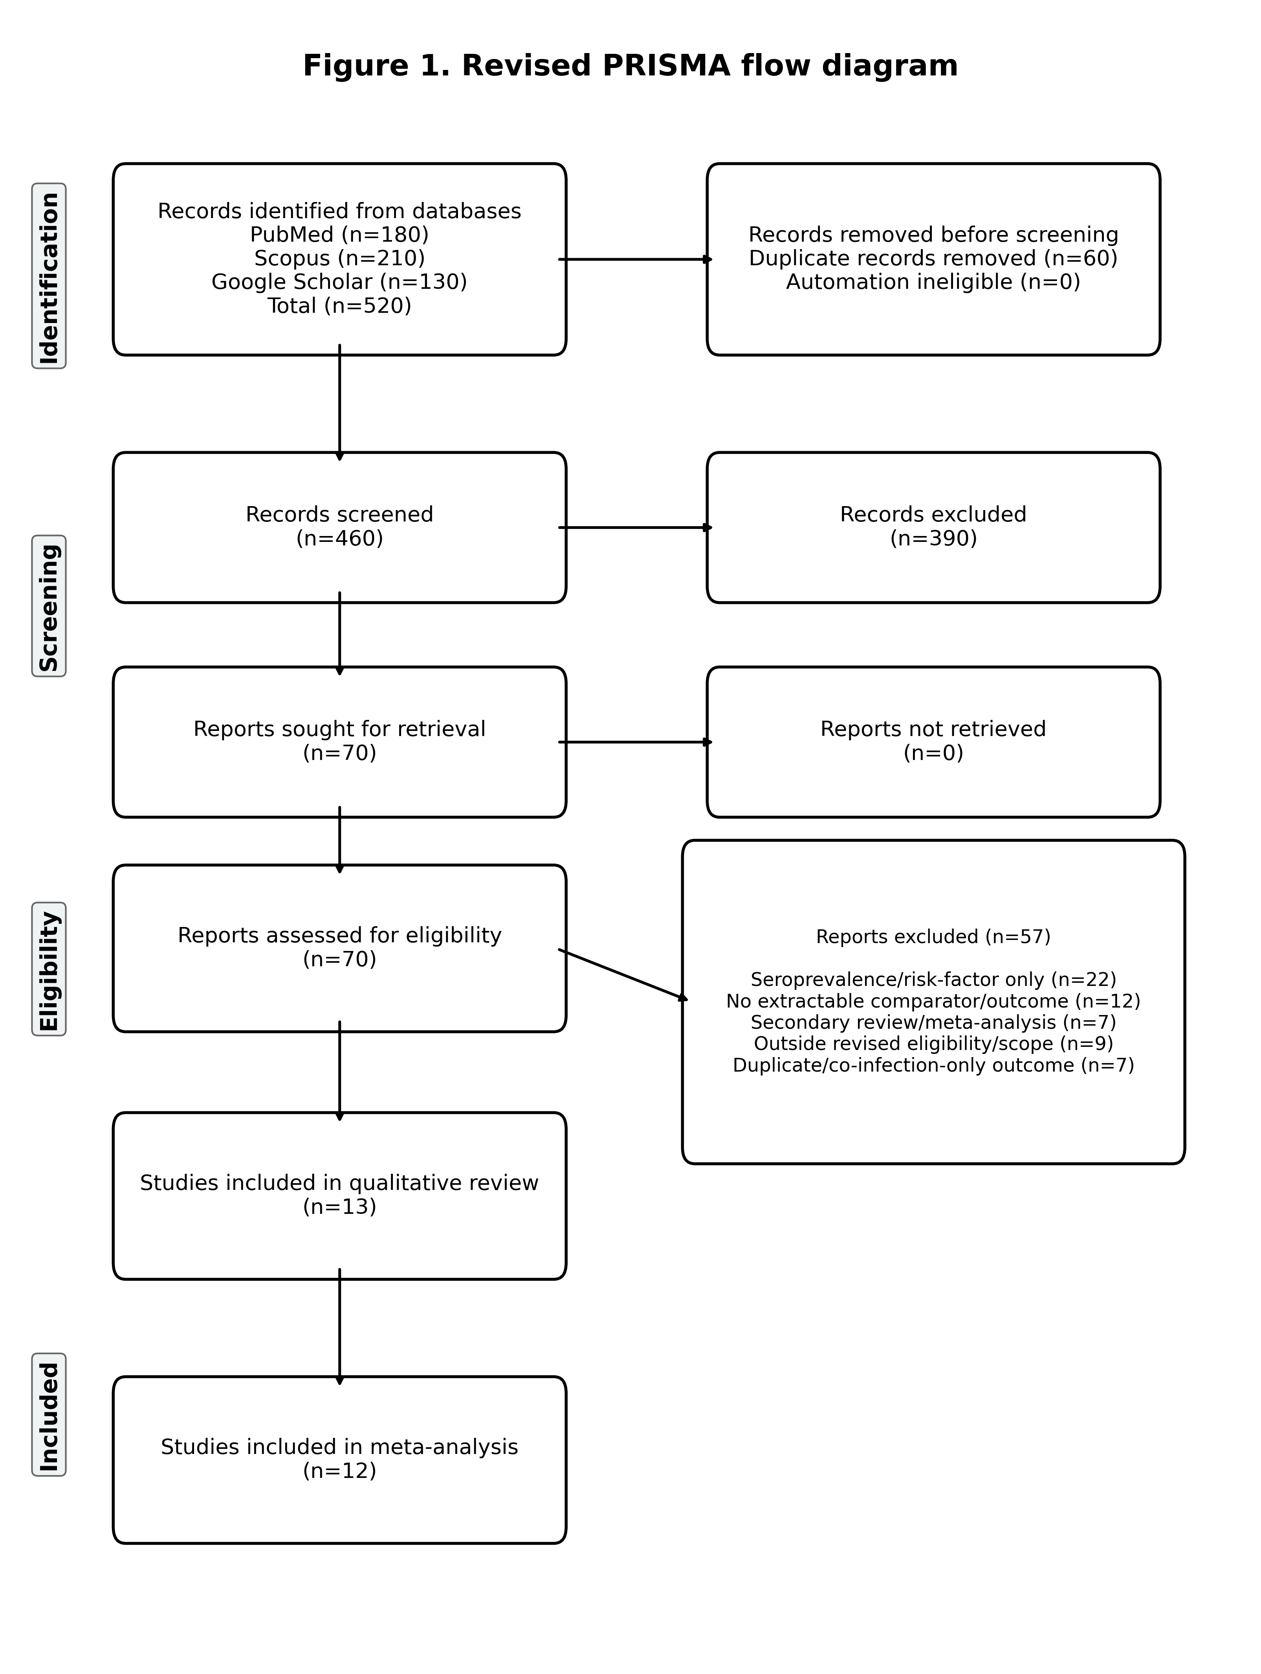
Figures

Figure 1. Revised PRISMA flow diagram showing database records, screened reports and studies retained for the revised qualitative and quantitative synthesis.

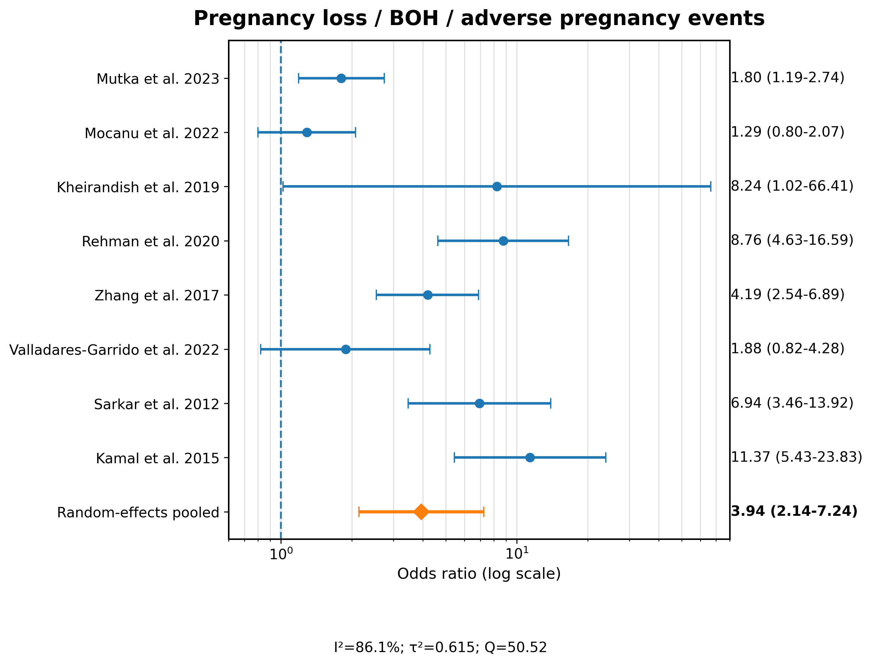

Figure 2. Forest plot for pregnancy loss, bad obstetric history and related adverse pregnancy events.

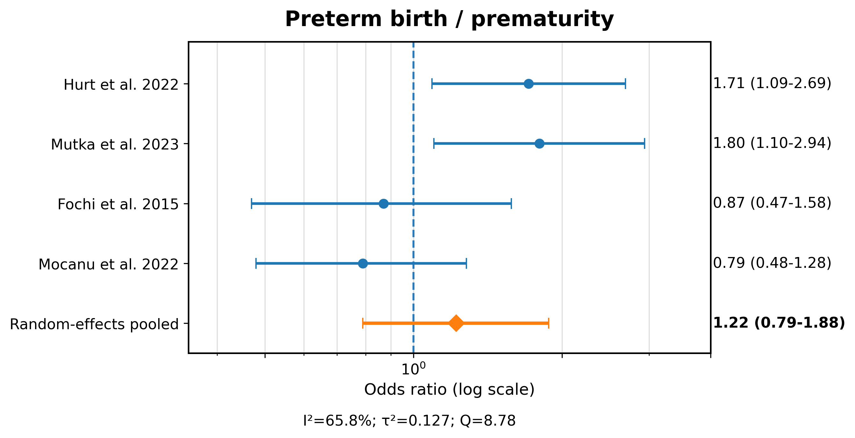

Figure 3. Forest plot for preterm birth and prematurity.

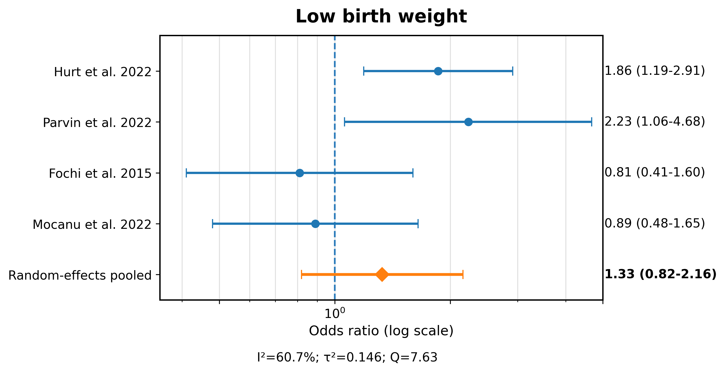

Figure 4. Forest plot for low birth weight.

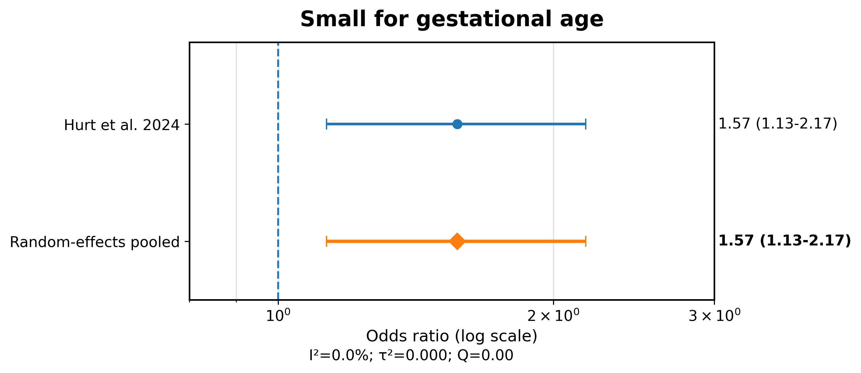

Figure 5. Forest plot for small-for-gestational-age birth.

